|  |  |  |  |  |  |  |
| --- | --- | --- | --- | --- | --- | --- |
|  | **Læringsforudsætninger** | **Mål** | **Rammefaktorer** | **Indhold** | **Læreprocesser** | **Vurdering** |
| **Emne** |  |  |  |  | Group work |  |

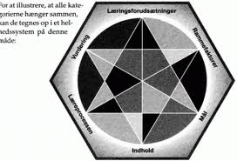

Timeplan

|  |  |  |  |  |
| --- | --- | --- | --- | --- |
|  | **Warm-up** | **Main Content** | **Evaluation** | **Homework** |
| **Lesson 1** |  |  |  |  |
| **Lesson 2** |  |  |  |  |
| **Lesson 3** |  |  |  |  |
| **Lesson 4** |  |  |  |  |

**Viderearbejde**